Class 7

**Lecture 12**

**Web**

**Web Development**

**Internet**

**&**

**Web**



**Lab Objectives:**

* Web Development.
* Web Design Technology
* Web Development Technology.

**What is Web Development?**

Web development broadly refers to the tasks associated with developing websites for hosting via Internet. The web development process includes web design, web content development, client-side/server-side scripting and network security configuration, among other tasks.



Web Technology

1. HTML

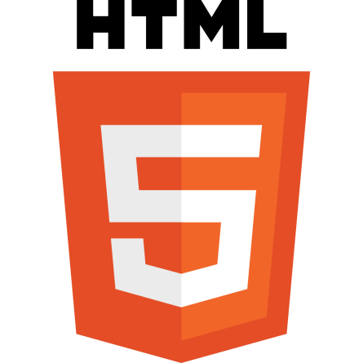

Hypertext Markup Language (HTML) is the standard markup language for creating web pages and web applications. With Cascading Style Sheets (CSS) and JavaScript, it forms a triad of cornerstone technologies for the World Wide Web.

Web browsers receive HTML documents from a web server or from local storage and render the documents into multimedia web pages. HTML describes the structure of a web page semantically and originally included cues for the appearance of the document.

HTML was developed by W3C & WHATWG and first introduced in 1993.

1. CSS

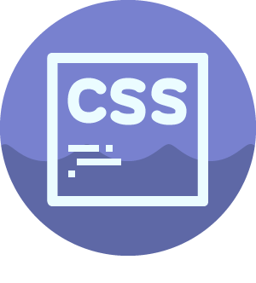

Cascading Style Sheets (CSS) is a style sheet language used for describing the presentation of a document written in a markup language like HTML. CSS is a cornerstone technology of the World Wide Web, alongside HTML and JavaScript.

CSS is designed to enable the separation of presentation and content, including layout, colors, and fonts. This separation can improve content accessibility, provide more flexibility and control in the specification of presentation characteristics, enable multiple web pages to share formatting by specifying the relevant CSS in a separate .css file, and reduce complexity and repetition in the structural content. Developed by W3c in 1996.

1. JavaScript

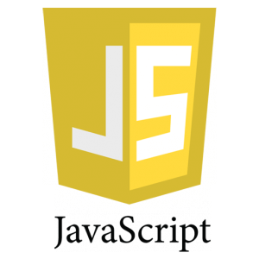

JavaScript is the programming language of HTML and the Web. JavaScript is easy to learn.

Alongside HTML and CSS, JavaScript is one of the three core technologies of the World Wide Web. JavaScript enables interactive web pages and thus is an essential part of web applications. The vast majority of websites use it, and all major web browsers have a dedicated JavaScript engine to execute it.

1. php

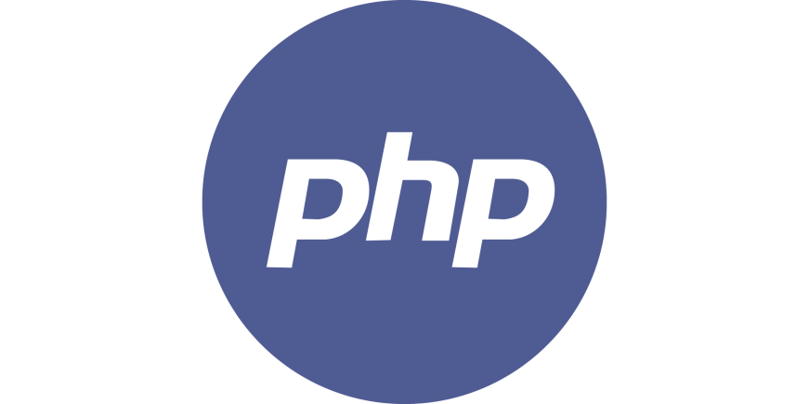

PHP is a powerful tool for making dynamic and interactive Web pages.PHP is a widely-used, free, and efficient alternative to competitor.

Hypertext Preprocessor (or simply PHP) is a server-side scripting language designed for Web development, but also used as a general-purpose programming language. It was originally created by Rasmus Lerdorf in 1994, the PHP reference implementation is now produced by The PHP Group. PHP originally stood for Personal Home Page, but it now stands for the recursive acronym PHP: Hypertext Preprocessor.

PHP code may be embedded into HTML code, or it can be used in combination with various web template systems, web content management systems, and web frameworks.

1. ASP .net



ASP.NET is an open-source server-side web application framework designed for web development to produce dynamic web pages. It was developed by Microsoft to allow programmers to build dynamic web sites, web applications and web services. It was first released in January 2002 with version 1.0 of the .NET Framework.

* Easy to learn, understand, and use
* Uses an SPA application model (Single Page Application)
* Similar to PHP and Classic ASP
* VB (Visual Basic) or C# (C sharp) scripting languages